**Assignment -2**

IBM CLOUD DB2

|  |  |
| --- | --- |
| Assignment Date | 26 OCTOBER 2022 |
| Student Name | DEEPIKA D |
| Student Roll Number | 711719104022 |
| Maximum Marks | 2 Marks |

**Questions:**

1. Create User table with user with email, username, roll number, password.

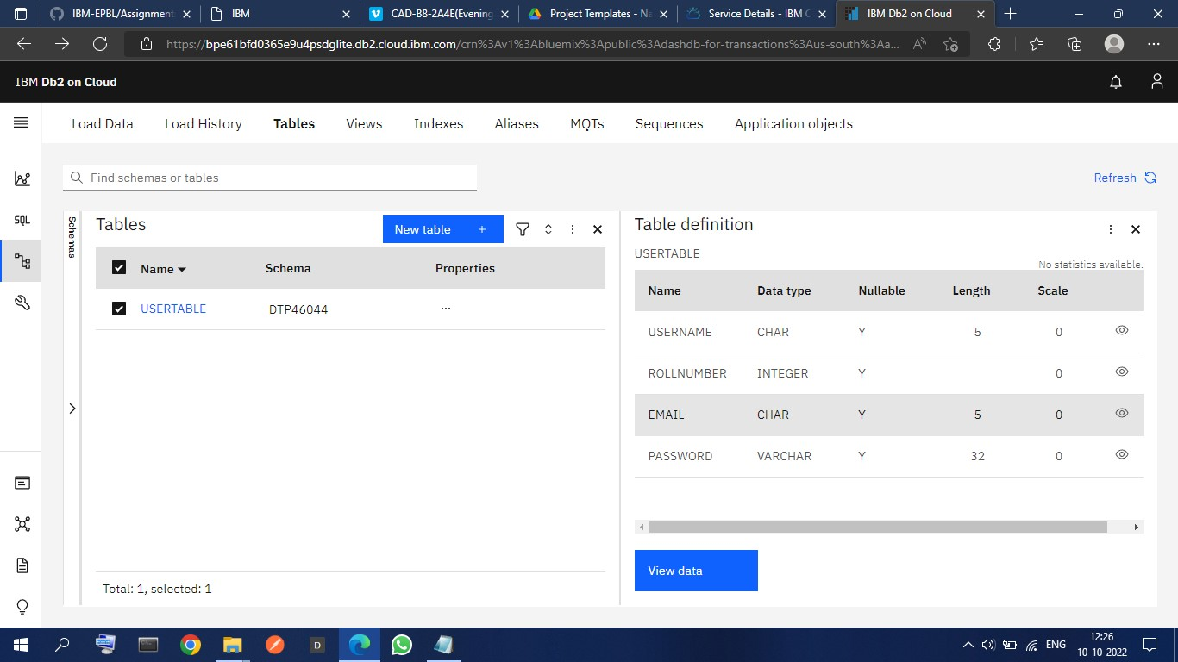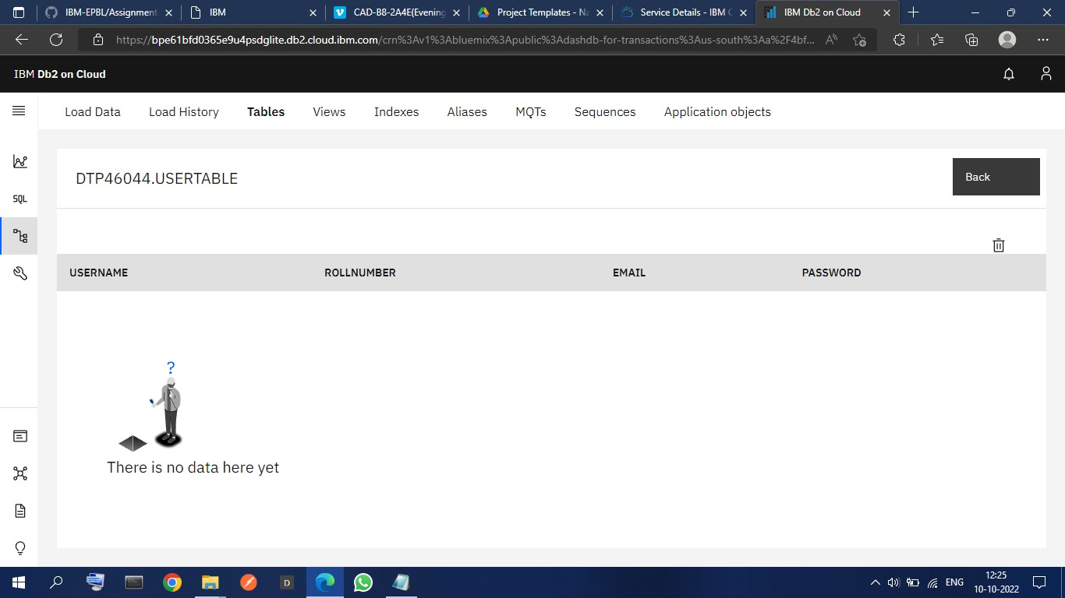

1. Perform UPDATE,DELETE Queries with user table.

# UPDATE TABLE:-

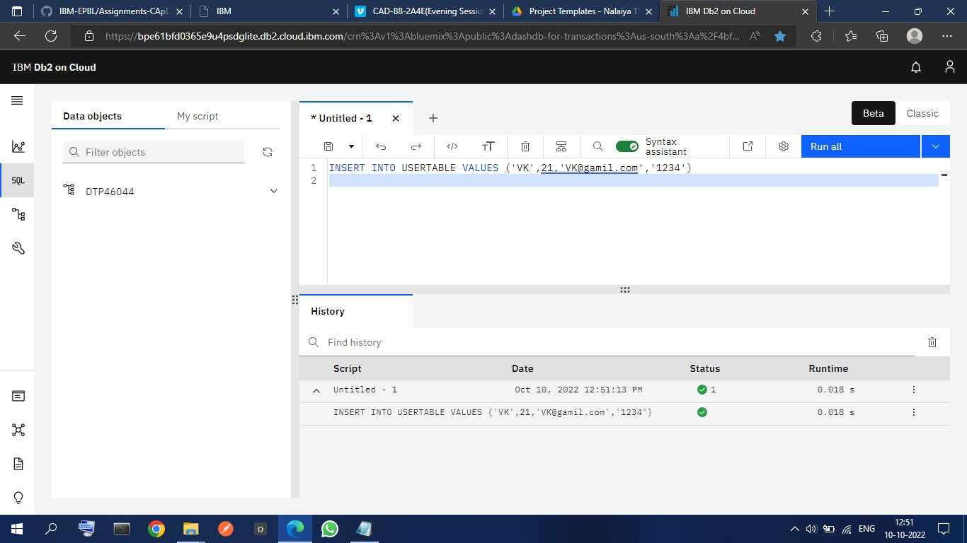

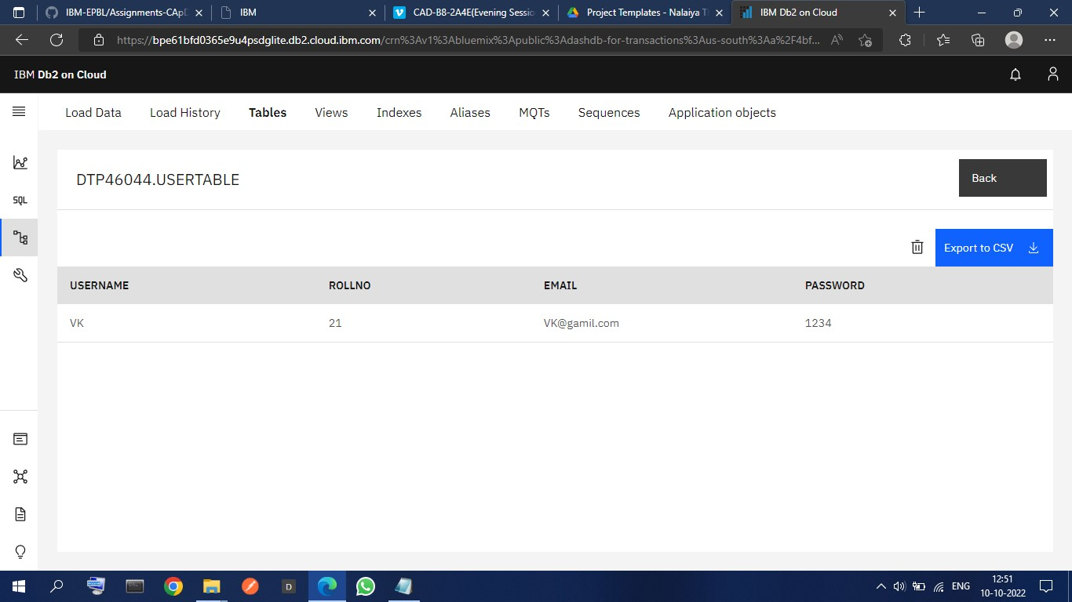

# DELETE TABLE:-

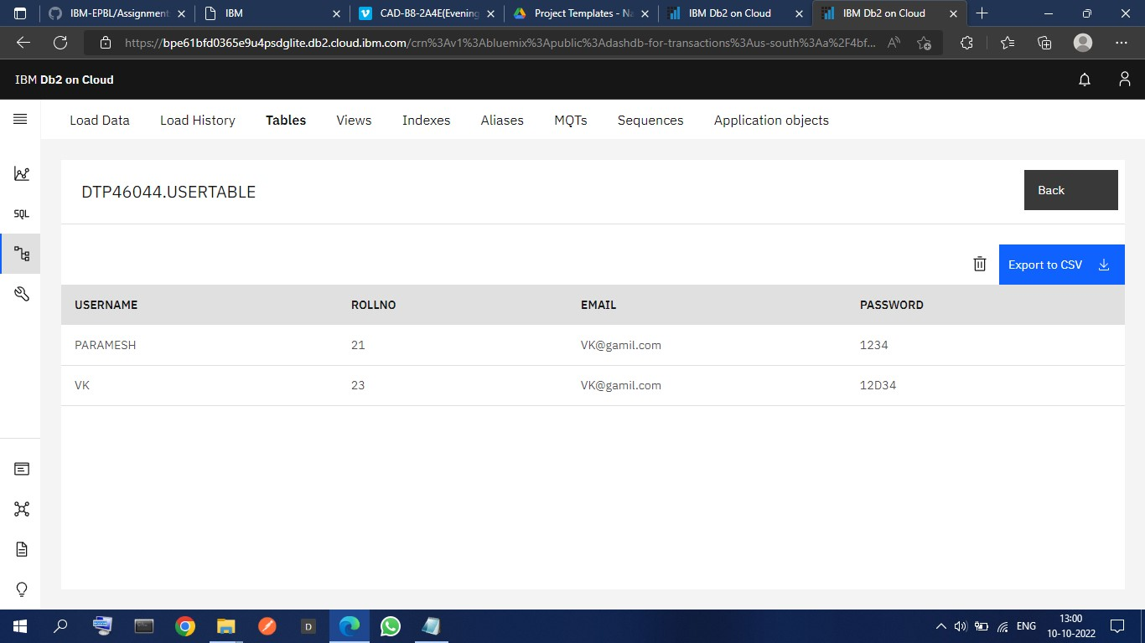

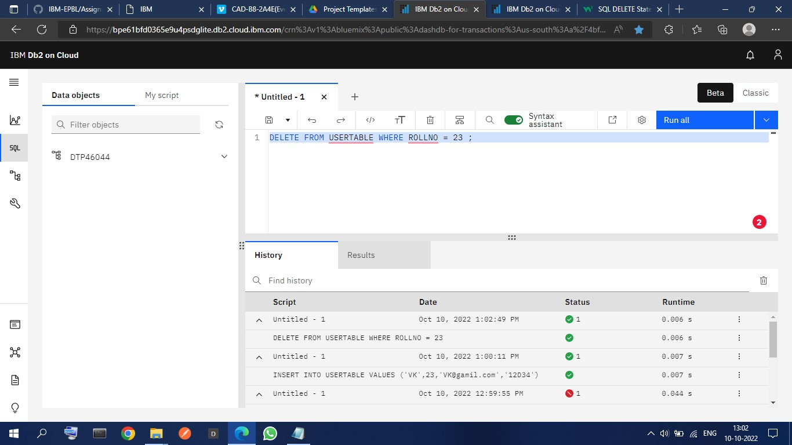

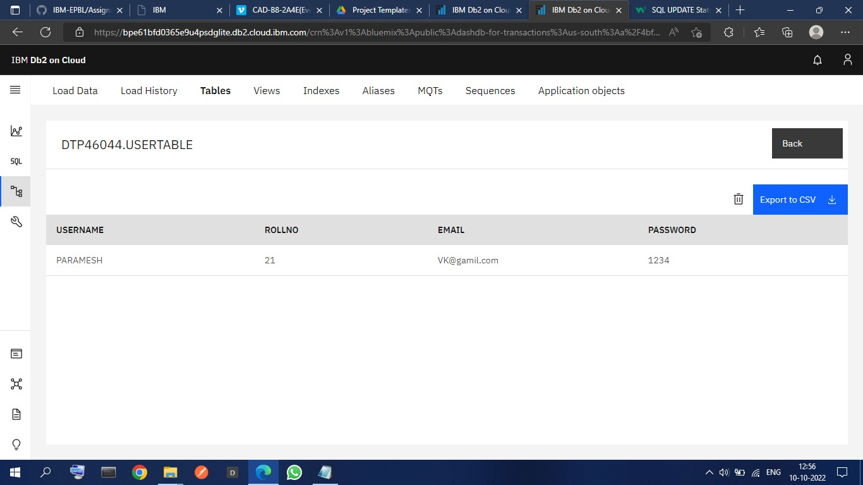

3.Connect python code to db2.

# NOTE : - Question 4 contains Question 3 answer

4. Create a flask app with registration page, login page and welcome page. By default load the registration page once the user enters all the fields store the data in database and navigate to login page authenticate user username and password. If the user is valid show the welcome page

**Answers**

# App.py

|  |
| --- |
| *from* flask *import* Flask, render_template, request, redirect, url_for, session *import* ibm_db *import* re    app = Flask(__name__)  app.secret_key = 'a'    conn = ibm_db.connect(  "DATABASE=bludb;HOSTNAME=fbd88901-ebdb-4a4f-a32e-  9822b9fb237b.c1ogj3sd0tgtu0lqde00.databases.appdomain.cloud;PORT=32731;USERNAM E=dtp46044;PASSWORD=95soX0sZGhb4ToUj;SECURITY=SSL;SSLSERVERCERTIFICATE=DigiCer tGlobalRootCA.crt;", "", "")  @*app*.*route*("/", methods=['GET', 'POST']) def *register*(): msg = '' *if* request.method == 'POST':  username = request.form['username'] |

|  |
| --- |
| email = request.form['email'] password = request.form['password'] sql = "SELECT * FROM users WHERE username =?" stmt = ibm_db.prepare(conn, sql) ibm_db.bind_param(stmt, 1, username) ibm_db.execute(stmt) account = ibm_db.fetch_assoc(stmt) print(account) *if* account:  msg = 'Account already exists !' *elif* not re.match(r'[^@]+@[^@]+\.[^@]+', email):  msg = 'Invalid email address !' *elif* not re.match(r'[A-Za-z0-9]+', username):  msg = 'name must contain only characters and numbers !' *else*:  insert_sql = "INSERT INTO users VALUES (?, ?, ?)" prep_stmt = ibm_db.prepare(conn, insert_sql) ibm_db.bind_param(prep_stmt, 1, username) ibm_db.bind_param(prep_stmt, 2, email) ibm_db.bind_param(prep_stmt, 3, password) ibm_db.execute(prep_stmt) msg = 'You have successfully registered !' *elif* request.method == 'POST':  msg = 'Please fill out the form !'  *return* render_template('register.html', msg=msg)  @*app*.*route*('/login', methods=['GET', 'POST']) def *login*(): *global* userid msg = ''  *if* request.method == 'POST':  username = request.form['username'] password = request.form['password']  sql = "SELECT * FROM users WHERE username =? AND password=?" stmt = ibm_db.prepare(conn, sql) ibm_db.bind_param(stmt, 1, username) ibm_db.bind_param(stmt, 2, password) ibm_db.execute(stmt)  account = ibm_db.fetch_assoc(stmt) print(account) *if* account:  session['loggedin'] = True session['id'] = account['USERNAME'] userid = account['USERNAME'] session['username'] = account['USERNAME'] msg = 'Logged in successfully !' |
| msg = 'Logged in successfully !' *return* render_template('dashboard.html', msg=msg) *else*:  msg = 'Incorrect username / password !' *return* render_template('login.html', msg=msg)    *if* __name__ == '__main__': app.run(host='0.0.0.0')  # *app.run(debug=True)* |

# Register.html

<!DOCTYPE *html*>

<html *lang*="en">

<head>

<meta *charset*="UTF-8">

<meta *http-equiv*="X-UA-Compatible" *content*="IE=edge">

<meta *name*="viewport" *content*="width=device-width, initial-scale=1.0">

<title>Smart Fashion register</title>

<!-- *bootstrap css cdn* --> <link *rel*="stylesheet" *href*="https://stackpath.bootstrapcdn.com/bootstrap/4.5.2/css/bootstrap.min.css

"

*integrity*="sha384-

JcKb8q3iqJ61gNV9KGb8thSsNjpSL0n8PARn9HuZOnIxN0hoP+VmmDGMN5t9UJ0Z" *crossorigin*="anonymous">

<link *rel*="stylesheet" *href*="https://cdnjs.cloudflare.com/ajax/libs/fontawesome/4.7.0/css/font-awesome.css">

<!-- *css stylesheet* -->

<link *rel*="stylesheet" *href*="/static/css/style.css">

<!-- *font styles cdn* -->

<link *rel*="preconnect" *href*="https://fonts.gstatic.com">

<link

*href*="https://fonts.googleapis.com/css2?family=Alegreya&display=swap" *rel*="stylesheet"> <link

*href*="https://fonts.googleapis.com/css2?family=Alegreya:wght@600&display=swap" *rel*="stylesheet">

</head>

<body>

<!-- *bootstrap navbar* -->

<!-- *navbar ends* -->

<!-- *Login form* -->

<div *class*="login text-center mt-5">

|  |
| --- |
| <form *action*="/" *method*="post">  <h2 *class*="form-text-h2"> Register Form </h2>  <div *class*="msg">{{ msg }}</div>  <input *type*="text" *class*="form-control" *name*="username" *placeholder*="Enter Your Username" *id*="username" *required*>  <input *type*="email" *class*="form-control" *name*="email" *placeholder*="Enter Your Email ID" *id*="email" *required*>  <input *type*="password" *class*="form-control" *name*="password" *placeholder*="Enter Your Password" *id*="password" *required*>  <button *type*="submit" *id*="button" *class*="btn btn-primary">  Register </button>  <div *class*="note mt-3 text-center">  <!--*Register form* -->  <p> already have an account ? please login <a *href*="/login">login! </a> </p>    </div>  </form>    </div>    </body>  </html> |

# Login.html

|  |
| --- |
| <!DOCTYPE *html*>  <html *lang*="en">    <head>  <meta *charset*="UTF-8">  <meta *http-equiv*="X-UA-Compatible" *content*="IE=edge">  <meta *name*="viewport" *content*="width=device-width, initial-scale=1.0">  <title>Smart Fashion Login</title>  <!-- *favicon* -->  <!-- *<link rel="shortcut icon" href="/assets/img/favicon.ico" type="image/x-icon">* -->  <!-- *<link rel="icon" href="/assets/img/favicon.ico" type="image/x-icon">* -->  <link *rel*="icon" *type*="image/png" *sizes*="16x16" *href*="/assets/img/favicon32x32.png">  <!-- *bootstrap css cdn* --> <link *rel*="stylesheet"  *href*="https://stackpath.bootstrapcdn.com/bootstrap/4.5.2/css/bootstrap.min.css  " |

|  |
| --- |
| *integrity*="sha384-  JcKb8q3iqJ61gNV9KGb8thSsNjpSL0n8PARn9HuZOnIxN0hoP+VmmDGMN5t9UJ0Z" *crossorigin*="anonymous">  <link *rel*="stylesheet" *href*="https://cdnjs.cloudflare.com/ajax/libs/fontawesome/4.7.0/css/font-awesome.css">  <!-- *css stylesheet* -->  <link *rel*="stylesheet" *href*="/static/css/style2.css">  <!-- *font styles cdn* -->  <link *rel*="preconnect" *href*="https://fonts.gstatic.com">  <link *href*="https://fonts.googleapis.com/css2?family=Alegreya&display=swap" *rel*="stylesheet">  <link *href*="https://fonts.googleapis.com/css2?family=Alegreya:wght@600&display=swap" *rel*="stylesheet">  </head>    <body>    <div *class*="login text-center mt-5">    <form *action*="/login" *method*="post">  <h2 *class*="form-text-h2"> Login Form </h2>  <div *class*="msg">{{ msg }}</div>  <div *class*="form-group mb-3">  <label *class*="label" *for*="username">Username</label>  <input *type*="text" *class*="form-control" *placeholder*="Username" *name*="username" *required*>  </div>  <div *class*="form-group mb-3">  <label *class*="label" *for*="password">Password</label>  <input *type*="password" *class*="form-control" *placeholder*="Password" *name*="password" *required*>  </div>    <button *type*="submit" *id*="button" *class*="btn btn-primary"> Login </button>  <div *class*="note mt-3 text-center">  <!--*Register form* -->  <p> Don't have an account yet? Click here to <a *href*="/">register! </a> </p> </div>  </form>  </div>    </body>  </html> |

# Style.css

|  |
| --- |
| * { margin: 0; padding: 0;  }  body { background-color: aqua !important; display: flex; flex-direction: column; align-items: center; justify-content: center;  } form { display: flex; flex-direction: column; align-items: center; justify-content: center; background-color: white; width: 40%; height: 450px; border-radius: 50px; margin: 100px; gap: 25px;    } h2 { font-size: large; font-weight: bolder;  } input {  width: 80% !important;  } div { display: flex; align-items: center; justify-content: center; flex-direction: column; width: 90%;  }    .*form-text-vk* { font-size: small; padding-bottom: 10px;  } |

.*form-text-h2* { font-size: x-large; padding-top: 10px;

}

# Output:- registration page:-

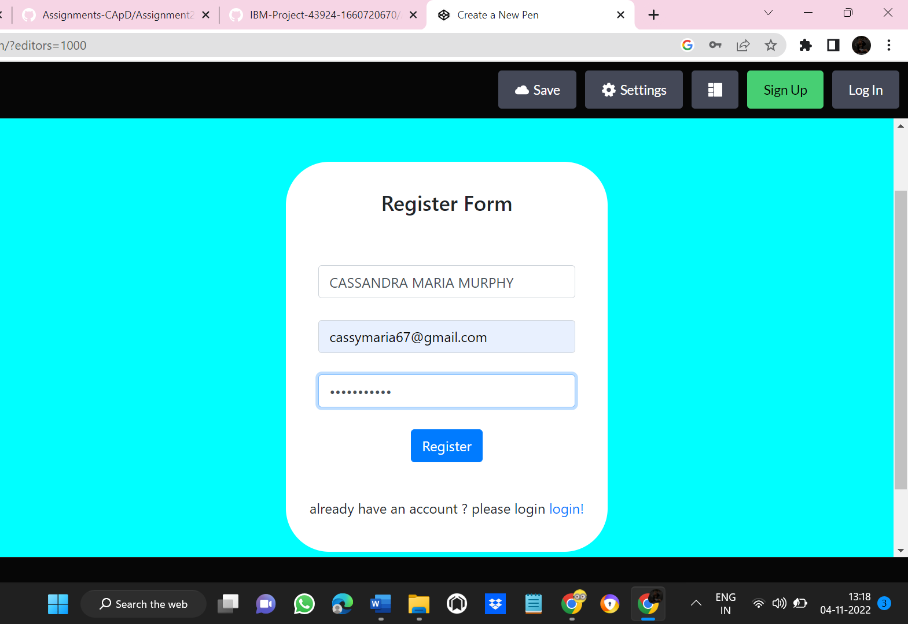Login Page:- 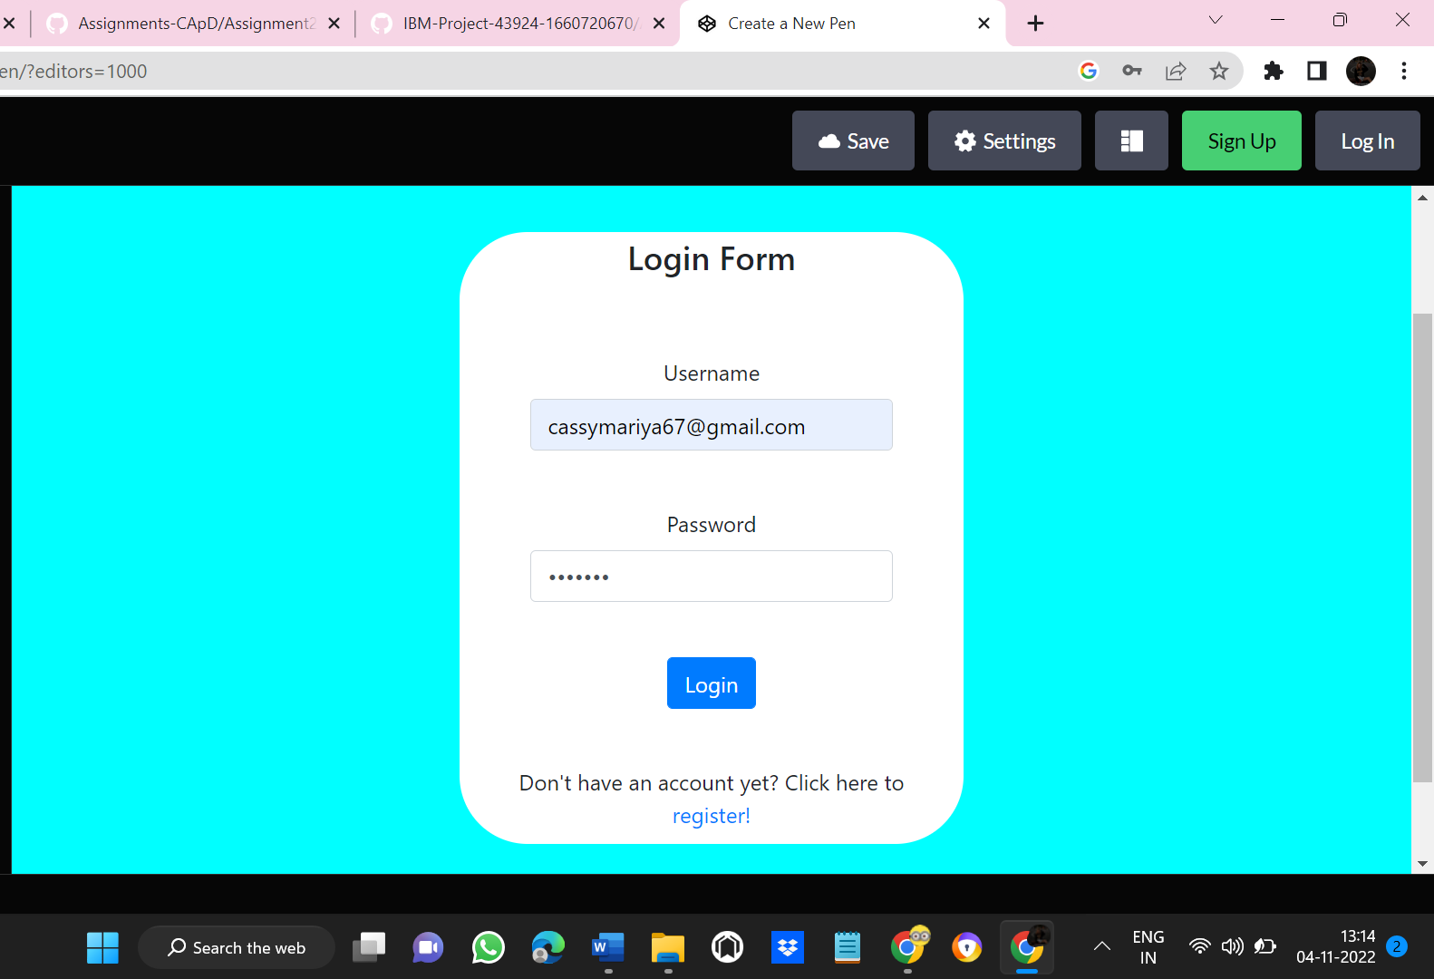

# Welcome Page:-

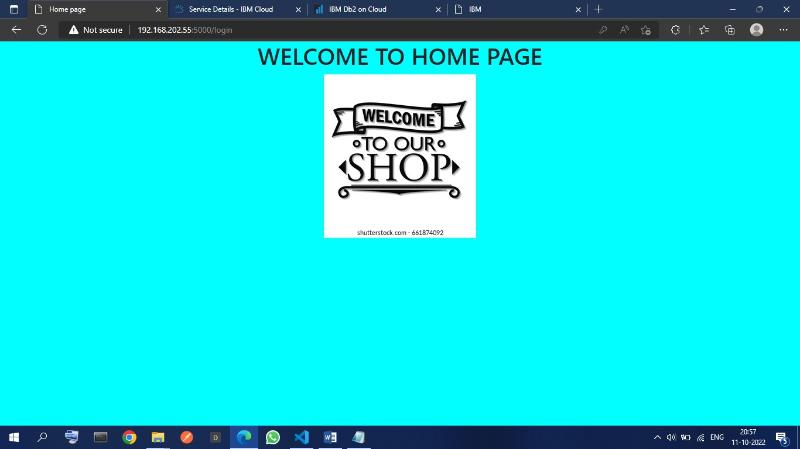

# Data Base Table :-